Dr.S.GANESH KUMARAN
+91 9677 624 378 ganeshphd4u@gmail.com www.ganeshphd4u.weebly.com
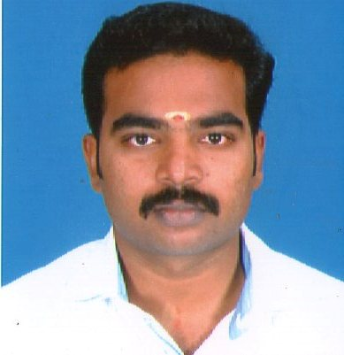
Qualifications
------------------------------------------------------------------------------------------------
Degree | Year of Passing | University | CGPA / % of Marks
Ph.D. Engg  (Electrical & Electronics Engg) | 2017 | Annamalai University, Chidambaram | Highly Recommended
M.E  (Power System) | 2011 | Annamalai University, Chidambaram | 1st Class  (8.23 CGPA)
M.B.A  (Human Resource Management) | 2011 | Annamalai University, Chidambaram (DDE) | 1st Class  (65 %)
B.Tech  (Electrical & Electronics Engg) | 2008 | Pondicherry University, Puducherry | 1st Class  (6.91 CGPA)

Experience
------------------------------------------------------------------------------------------------
Position | Industry / Institution | Period
Associate Professor | Sri Manakula Vinayagar Engineering College | 2nd July 2018 – Till Date
Associate Professor | Sri Shakthi Institute of Engineering and Technology | 29th Jan 2018 – 29th June 2018
Assistant Professor | Arunai Engineering College,  Tiruvannamalai | 23rd May 2012 – 18th Jan 2018
Assistant Professor | Dr.SJS Paul Memorial College of Engineering & Technology, Puducherry | 21st May 2011 –15th May 2012
Electrical Safety Engineer | Venus Power Tech,  Pondicherry | 1st June 2008 – 31st July 2009

Area of Interest
------------------------------------------------------------------------------------------------
- Smart Grid
- Transmission and Distribution
- FACTs
- Renewable Energy Sources
Reviewer
------------------------------------------------------------------------------------------------
- Reviewer in Renewable & Sustainable Energy Reviews (Elsevier)
Academic Honors and Awards Received
------------------------------------------------------------------------------------------------
- Power Plant Engineering (Best Faculty Certificate Award for 100% result)
- Principles of Management (Best Faculty Cash Award for 100% result)
- Basic Electrical and Electronics (Best Faculty Cash Award for 100% result)
- Second Prize in Project Expo conducted by Anna University, Panruti.
- Second Prize in Project Expo conducted by TAFE.
- Best Innovative Project Appreciation by Arunai Engineering College. (Annex -I)
- Best Innovative Project Award by TAFE. (Annex -II)
- GATE 2011 Qualified with 87.02 percentile.
- Third Prize for Renewable energy project conducted by SMVEC, Puducherry.
- Practical Examiner (Annamalai and Anna University)
- Acted as Chief Guest for S³-HALCONS EEE department symposium, conducted by VRS College of Engineering and Technology dated on 20.09.2018. (Annex -III)
Academic Projects
------------------------------------------------------------------------------------------------
Ph.D Dissertation:
“SMART GRID APPLICATIONS IN DISTRIBUTION SYSTEMS”
Description: The structure of the designed model consists of PV system with Maximum Power Point Tracking (MPPT) method, DC-DC boost converter, BPI, UPI, Static Compensator (STATCOM) and GCES. If PV power directly provides for huge loads may result in the huge sizing of the panel. The solution for this problem is overcome by automatic control of duty cycle for the Direct Current (DC)-DC converter, which is typically inserted between the solar panel and the load. Therefore, so as to fulfill the huge load demand, Grid Connected Energy Systems (GCES) is designed for single phase and three phase Bipolar Inverter (BPI) and Unipolar Inverter (UPI) with PV systems using Fuzzy Logic Controller (FLC) plus Proportional Integral (PI) controller.
Incremental Conductance technique based MPPT is used to derive the control signal for DC-DC boost converter in maximum power operating conditions to produce the DC voltage for BPI, UPI grid connected inverter. The Sinusoidal Pulse Width Modulation technique is used to generate the pulses for BPI, UPI to improve the power quality parameters.
This work also presents a novel hybrid controller which is the combination of FLC cum Hysteresis Current Controlled STATCOM for enhancing the Power Quality and to reduce Total Harmonic Distortion in power system at various load operating conditions. In addition to this the experimental prototype model of Smart Meter is designed to make use of enhanced power with wholehearted consumer satisfaction. Various outputs are obtained and presented.

Copyrights
------------------------------------------------------------------------------------------------
- Received a copyright for a new business module titled “Training based business Scheme to transform untrained Engineers to Smart Trained Engineers”.(Annex-IV)

Responsibility
------------------------------------------------------------------------------------------------
- Created a Cypress Semiconductor University Alliance (CUA) Program.
- Received 308.30 US Dollar (Rs.22, 357) worth kit for Sri Manakula Vinayagar Engineering College, Puducherry.
- Certificated trainer for ENTREPRENEURSHIP DEVELOPMENT
- Organized IEEE One day National Level Workshop on “Embedded System Design Using PSoC 4” on 11th Aug 2018 at Sri Manakula Vinayagar Engineering College.
- Promoted innovator day 2018 associated with IEEE SSIT and Educational Society.
- Department Co-Coordinator for innovator day 2018 at Sri Manakula Vinayagar Engineering College.
- Department Coordinator for IEEE and R&D Activities at Sri Manakula Vinayagar Engineering College.
- Entrepreneur Cell Coordinator at Sri Shakthi Institute of Engineering and Technology.
- Class Advisor, Counselling and Guidance for EEE students at Sri Shakthi Institute of Engineering and Technology.
- NPTEL coordinator (SPOC) for Sri Shakthi Institute of Engineering and Technology.(Annex-V)
- NPTEL Mentor for Non-Conventional Energy Resources in Sri Shakthi Institute of Engineering and Technology.
- Framed Anna University syllabus for B.E-III semester EEE, VAC course.
- VIP Hospitality at Arunai Engineering College, Thiruvannamalai.
- Test Coordinator at Arunai Engineering College, Thiruvannamalai.
- Industrial Visit Coordinator at Arunai Engineering College, Thiruvannamalai.
- Class Advisor, Counseling and Guidance for III year EEE Students in Arunai Engineering College, Thiruvannamalai.
- Project Guide for U.G and P.G Students.
- Co-Coordinator for the EEE Department SEEE workshop at Arunai Engineering College, Thiruvannamalai.
- Workshop coordinator for National level workshop Conducted by Dr SJS PMCET, Puducherry.
- ISO coordinator at Dr SJS Paul Memorial College of Engineering and Technology, Puducherry.
- Class Advisor, Counseling and Guidance for II year EEE Students in Dr SJS Paul Memorial College of Engineering and Technology, Puducherry.

Workshop / Seminars Attended
------------------------------------------------------------------------------------------------
- IEEE madras section SSIT organized one day technical workshop on “Embedded System Design Using PSoC - 4”, held at EEE department Sri Manakula Vinayagar Engineering College, Puducherry, on 11th August 2018.
- Two days Faculty Development Programme conducted by ICT Academy on” 10 Attributes of an Outstanding Teacher” held at Sri Manakula Vinayagar Engineering College, Puducherry, on 06th and 07th July 2018.
- Forge Accelerator organized three days residential program “Entrepreneurial Educators” held at Forge headquarters, on May 24th – May 26th 2018.
- UGC Sponsored workshop on “Embedded control for PV Fed Electric Drive Systems” held at Annamalai University, on March 09th – 14th 2015.
- Two day Technical workshop on “Building Embedded Systems with ARM Cortex-M MCUs” Conducted by Dept. of EEE, Arunai Engineering College, Tiruvannamalai, on 22nd and 23rd Jan 2015.
- INDO-US Workshop organized by Tennessee Technological University, US and Annamalai university, Faculty of Engineering and Technology, International Workshop on “Emerging Trends in Energy Systems Management”, March 14th -16th 2014.
- NPTEL, IIT Madras & Arunai College of Engineering sponsored one day workshop on “NPTEL Technical Programs”, held at Arunai College of Engineering, Tiruvannamalai, on 13th July, 2013.
- PRDC sponsored national level workshop on “Smart Grid Technologies: Opportunities and challenges”, Organized by the school of Electrical Engineering, VIT Chennai on 5th Nov, 2013.
- IEEE madras section organized two days technical workshop on “MATLAB/ Simulink-Based Modeling and Analysis of power systems & power electronics”, held at department Arunai College of Engineering, Tiruvannamalai, from 1st to 2nd march 2013.
- IEEE madras section organized two days technical workshop on “Smart Grid”, held at Anna University, Gunidy from 25th to 26th August 2012.
- One day Technical workshop on “Multiphase AC drives and Fault diagnosis”, held at EEE department Arunai College of Engineering, Tiruvannamalai, on 9th August 2012.
- AICTE sponsored national seminar on “Recent Research in Bio-Inspired computing for Electrical Engineering Applications”, Organized by the department of Electrical and Electronics Engineering, CK college of Engineering & Technology, Cuddalore from 5th to 6th May 2012.
- Renewable Energy Agency of pondcherry sponsored seminar on “Renewable Energy-Energy for the Future” Organized by the department of Electrical and Electronics Engineering, Christ College of Engineering, Pondicherry, on 6th Sep 2011.

Short Term / Certificate Courses Attended
------------------------------------------------------------------------------------------------
- AICTE-QIP Sponsored One week Short Term Course on “Advanced Technology in Smart Grid” Organized by Dept. of EEE Comibatore Institute of Technology, on 2nd – 8th May 2016.
- AICTE-QIP Sponsored One week Short Term Course on “Power Quality Issues and Its Mitigation in Smart/Micro Grid Systems” Organized by Dept. of EEE Comibatore Institute of Technology, on 17th-23rd Nov 2014.
- IET Certified course on “Smart Grid and Integration of Distribution Energy Resources” along with Hands on PSCAD training, held at electrical engineering department Dr MGR University, Chennai from 19th to 21st April,2013.
- “PLC and SCADA Programming” from Control Logix.
- ATI, Chennai for “Maintenance and Servicing of AC - DC Power Supplies and UPS”.
Professional Memberships
------------------------------------------------------------------------------------------------
- Life Member of the Indian Society for Technical Education, New Delhi, India (M.No.: LM 103883)
- Member in International Association of Engineers, HongKong. (M.No.: 118755)
- Member in National Mission on Power Electronics Technology, GoI, India (NaMPET)
- Member of Renewable Energy Club in SMVEC, Madagadipet, Puducherry.
- Senior member in International Society for Research and Development, UK (SR4150900590).
- Member of Universal Association of Computer and Electronics Engineers, USA (AM1004814).

Book Publications
------------------------------------------------------------------------------------------------
Title | Author | Publisher
Energy Management System and its Developments in Smart Grid | S.Ganesh kumaran, C.R.Balamurugan  T.Sengolrajan | Lambert Publisher, Germany
Smart Grid and Its Development | S.Ganesh kumaran, C.R.Balamurugan | Lambert Publisher, Germany
Power System Transients | C.R.Balamurugan,  D.Periyaazhagar,  S.Ganesh kumaran | Sruthi Publishers,  Chennai
Electrical Machines-1 | C.R.Balamurugan,  S.Ganesh kumaran,  D.Periyaazhagar | Sruthi Publishers,  Chennai
Special Electrical Machines | C.R.Balamurugan,  D.Periyaazhagar,  S.Ganesh kumaran, | Sruthi Publishers,  Chennai
Electrical Energy Generation, Utilization and Conservation | C.R.Balamurugan,  A.N.Abirami,  S.Ganesh kumaran | Sruthi Publishers,  Chennai

Funded Research Projects Applied
------------------------------------------------------------------------------------------------
Title of the Project | Funding Agency | Year of Applied
Transformation Of ATM Into Safe, Secure, And Smart ATM | Tamil Nadu State Council For Science And Technology | 2014
Publications
------------------------------------------------------------------------------------------------
International Journals

- Dr.S.Ganesh kumaran and Dr.C.R.Balamurugan, (2018) Enhancement of smartness and security in ATM by Global system for mobile communication, Vol. 13(07), pp.2065–2083.Journal of Engineering Science and Technology. (Web of Science)
- Ganesh kumaran, S. and Singaravelu, S. (2016), Design and Implementation of Fuzzy Logic Controller cum Hysteresis Current Controlled STATCOM for Improving Power Quality, Indian Journal of Science and Technology, Vol. 9(45), pp.1–13.(SCOPUS, Web of Science)
- S.Ganesh kumaran,Dr.S.Singaravelu,C.Priya,Dr.T.S.Sivakumaran, Transformation of ATM into Safe, Secure and Smart ATM, International Journal Of Innovative Research In Electrical, Electronics, Instrumentation And Control Engineering(IJIREEICE), ISSN (Online) 2321 – 2004, ISSN (Print) 2321 – 5526, Vol. 2, Issue 9, September 2014, Impact Factor 1.112.
- S.Ganesh kumaran,Dr.S.Singaravelu,Dr.T.S.Sivakumaran, Novel Idea to Reduce Industrial Pollution by Monitoring and Controlling System Using Zigbee, i-manager’s Journal on Digital Signal Processing. V2(I2) Apr-Jun, 2014 Print ISSN 2321-7480, E-ISSN 2322–0368, pp, 10-15, Impact Factor 0.323.
- S.Ganesh kumaran, Dr.S.Singaravelu , K.Vivekanandan, Hybrid Energy System and its Modelling in Smart Grid, International Journal of Engineering Trends and Technology (IJETT), ISSN: 2231-5381 , Volume 11 Number 9 - May 2014,PP 409 – 413, Impact Factor 0.537.
- S.Ganesh kumaran, Dr.S.Singaravelu , K.Vivekanandan, Energy Management System and Developments in Smart Grid, International Journal of Development Research, ISSN: 2230-9926, Issue, 3, Vol. 4, March, 2014, PP. 647-653, Impact Factor 0.47.
- S.Ganesh kumaran, Dr.S.Singaravelu , K.Vivekanandan, Advance Technics, Challenges and Developments in Smart Grid System, International Journal of Engineering and Advanced Technology (IJEAT), ISSN: 2249 – 8958, Volume-3, Issue-1, October 2013, PP 107-114, Impact Factor: 1.097.
- S.Ganesh kumaran, Dr.S.Singaravelu , K.Vivekanandan,Advance Distribution Automation Systems and Its Development in Smart Grid, International Journal of Advanced Scientific and Technical Research, ISSN 2249-9954 Issue 3 volume 5, Sep.-Oct. 2013,PP 542-553, Impact Factor 2.94.
- Dr.S.Ganesh kumaran and Dr.C.R.Balamurugan, Intelligent Safety System for Motorcyclist Using Raspberry Pi with Embedded System, Journal of Electric Engineering. (Under Review)
- Dr.S.Ganesh kumaran and Dr.C.R.Balamurugan, Transformation of city to Smart City with Smart Devices, Journal of Electric Engineering. (Under Review)
International Conference
- S.Ganesh kumaran and P.Sakthivel, Design of Automatic Power Consumption Control System Using Smart Grid - A Review, Proceedings of 2016 World Conference on Futuristic Trends in Research and Innovation for Social Welfare (Startup Conclave), 29 Feb.-1 March 2016, Coimbatore, pp.no.1-4.
- S.Ganesh kumaran,Dr.S.Singaravelu,C.Priya,Dr.T.S.Sivakumaran, “ A Prototype model to improve the Security System of an ATM“ IEEE Spponsored 9th International Conference on Intelligent Systems and Control 2015,PP 860-865.
- S.Ganeshkumaran,Dr.S.Singaravelu,K.Sivabalaji,K.T.M.Mohamed “Novel Idea for Monitoring and detecting the bombs in railway networks” International Conference on Energy and Sustainability in Engineering Systems,16th-18th Dec 2014.
- S.Ganesh kumaran "A Novel Idea to Contribute Society for Secured, Safe ATM Service Notification Display Unit " International Conference on Emerging Trends in Science, Engineering, Business and Disaster Management published in journal of Emerging Technologies, Image Processing and Networking, ISSN No: 0973-2993, Volume:8,Special Issue I, Feb 2014,PP 143 - 147.
- S.Ganesh kumaran "A Novel Idea to Computerized Industrial Pollution Monitoring and Controlling System" International Conference on Emerging Trends in Science, Engineering, Business and Disaster Management published in journal of Emerging Technologies, Image Processing and Networking, ISSN No: 0973-2993, Volume:8,Special Issue I, Feb 2014,PP 138 - 142.
- S.Ganesh kumaran “A Novel Method To Integrate Smart Grid Approach Into Solar Powered ATM Centers" International Conference on Emerging Trends in Science, Engineering, Business and Disaster Management published in journal of Emerging Technologies, Image Processing and Networking, ISSN No: 0973-2993, Volume:8,Special Issue I, Feb 2014,PP 201 – 204.
- S.Ganesh kumaran ”Green and Smart” Home Automation using Embedded Controller, International Conference on Systems, Methodologies, Automation and Research trends, pp T1-32, Dec 12-14 ,2012, SMVEC, Puducherry, India.
- S.Ganesh kumaran “Modeling and Simulation of Photovoltaic Renewable Energy Power Systems “International Conference on Futuristic Trends in Electronics Engineering (ICFTEE-2012), pp36-42.
- S.Ganesh kumaran “A Hybrid Artificial Bee Colony Algorithm for Economic Dispatch with Non-Convex cost Function” International Conference on Futuristic Trends in Electronics Engineering (ICFTEE-2012),pp 25-29.
Innovative Projects guided:
------------------------------------------------------------------------------------------------
- Novel Idea for Monitoring and Detecting Explosives in Railway Network.
- A Novel Idea to Reduce Energy Consumption in ATM Centers through Renewable Energy Sources.
- Hybrid E-Bicycle Using Green Energy for Smart Grid Environment.
- A Transformation of City to Smart City Using Smart Devices.
- Control Measure to Prevent Currency Theft Using RF Tag.
- Transformation of ATM into Secure and Smart Atm.
Funded Research Proposal’s:
------------------------------------------------------------------------------------------------
- Monitoring and detecting explosives in railway network.

- A novel idea to reduce energy consumption in ATM centres through renewable energy sources.

Consolidation
------------------------------------------------------------------------------------------------
Sl.no | Name of the Event | Total  On-Progress | Total Completed
1 | Journals | 02 | 08
2 | Conferences | - | 09
3 | FDP/STC | - | 14
4 | Academic Honors and Awards | - | 09
5 | Funded Research Projects Applied | 02 | -
6 | Book Published | - | 06
7 | Reviewer | - | 01
8 | UG & PG project guided | - | More Than 16

Contact Address
------------------------------------------------------------------------------------------------
Name | : Dr.S.Ganesh kumaran
Age & DOB | : 31 Years & 26.11.1986
Sex | : Male
Marital Status | : Married
Nationality | : Indian
Father’s Name | : S.Subburayan
Mother’s Name | : S.Sivagangai
Permanent Address | : Old No.95, new no 31, IIIrd cross, Manikachettiyar nagar,  Shanmugapuram, Puducherry 605009
Languages Known | : English, Tamil
Mobile No / Email-ID | : +91 9677 624 378 / ganeshphd4u@gmail.com

References
------------------------------------------------------------------------------------------------
Dr.S.Singaravelu,  Professor/EEE,  Annamalai University,  Chidambaram. | Dr.M.Arumugam,  Former Director,  National Institute of Technology,  Tiruchirappalli. | Dr.G.Ravi,  Professor/EEE,  Pondicherry Engg College,  Pondicherry.

Dr.P. Kanagavel,
Scientist & Additional Director,
Research and Development(R&D), ITCS & IT,
Centre for Wind Energy Technology - Govt.of India,
Chennai.

Prof.D.Karthikesan,  Outstanding Scientist,  Former Director-ISRO,  Prof Satish Dhawan Scientist,  Vikram Sarabhai Space Center,  Tirvandrum. | Er.S. Senthilkumar,  Assistant Director,  NPTI-Southern Region,  Block-14, Neyveli.
DECLARATION
------------------------------------------------------------------------------------------------
I hereby declare that the above written particulars are true to the best of my knowledge and belief.

Place: Puducherry Signature
Date: 

(Dr.S.Ganesh kumaran)

Annex –I

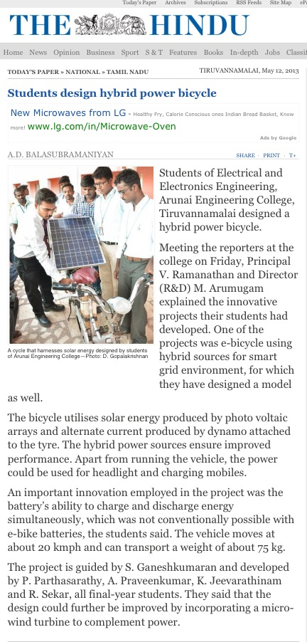
Ref:- http://www.thehindu.com/todays-paper/tp-national/tp-tamilnadu/students-design-hybrid-power-bicycle/article4708308.ece
Annex –II

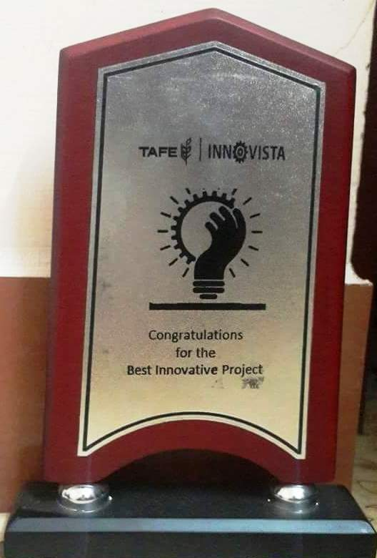

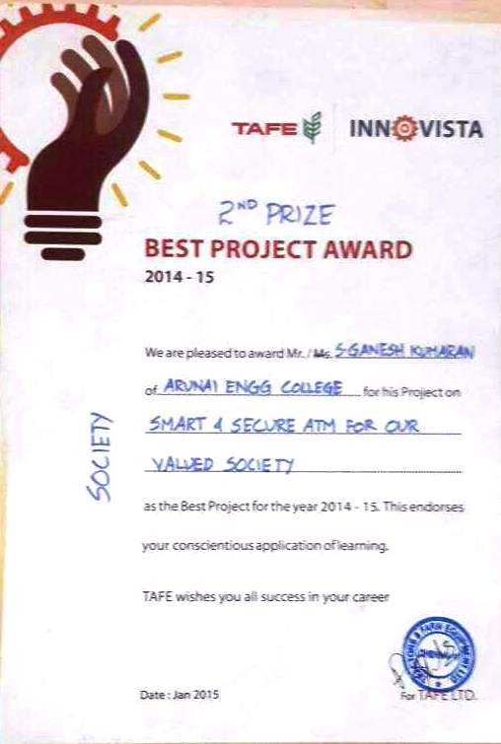
Annex –III

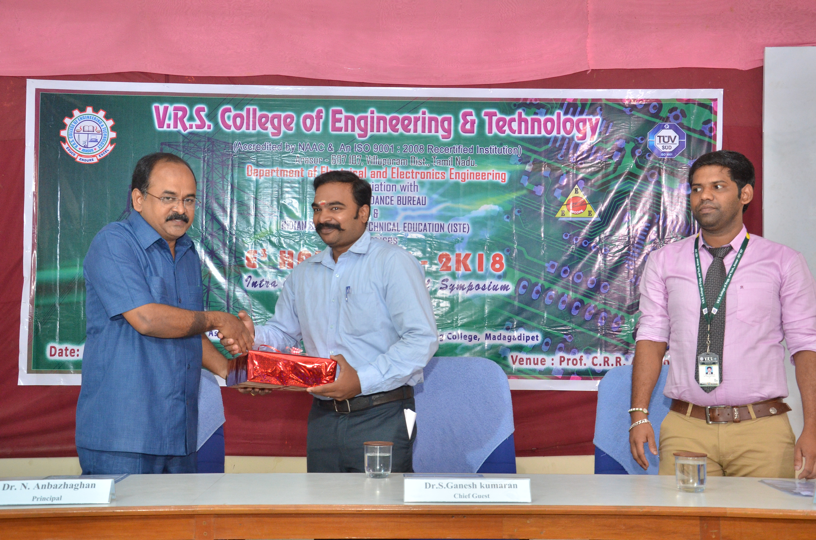

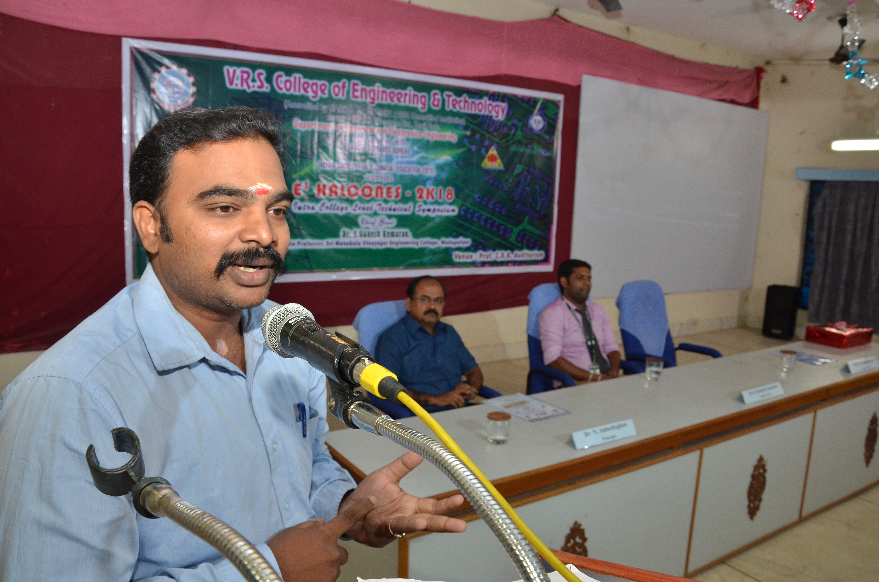

Annex –IV
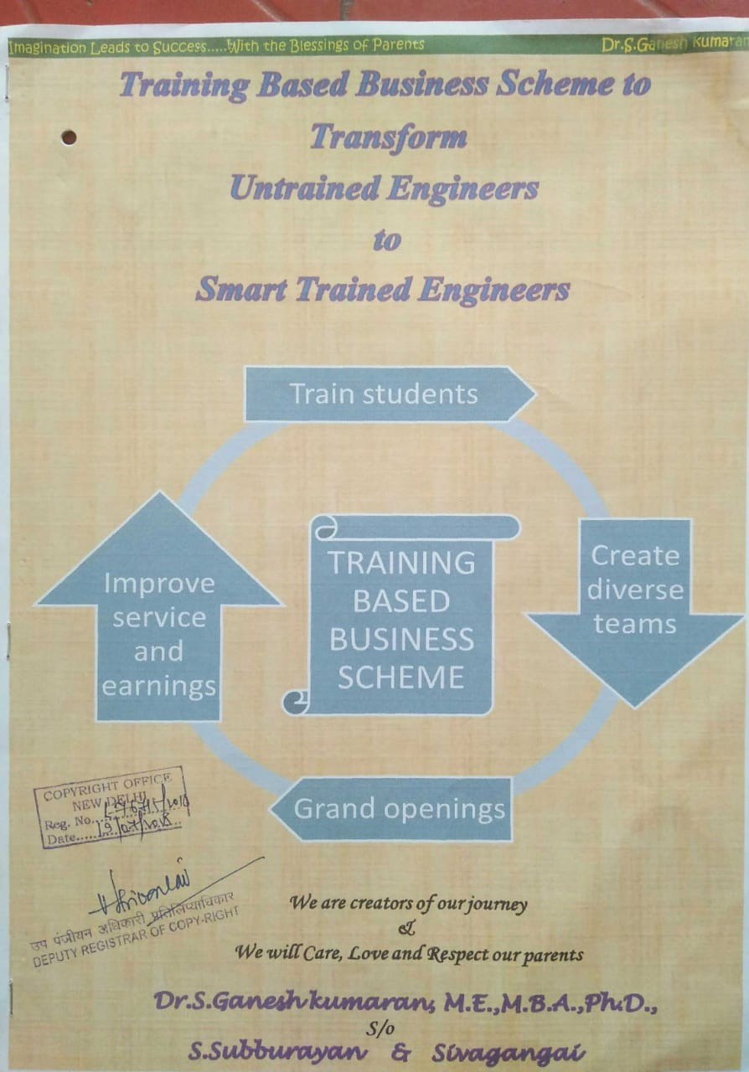
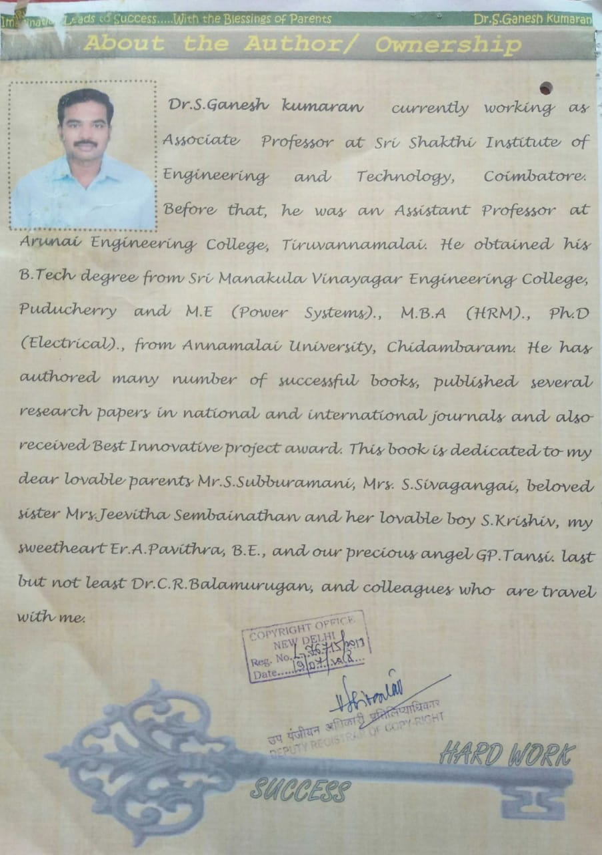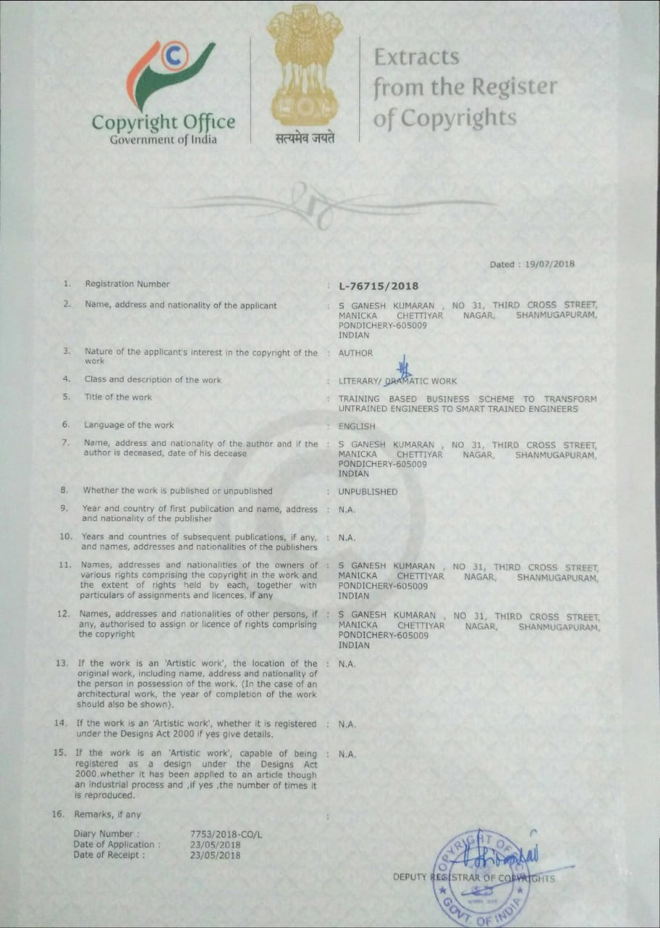
Annex-V


